THE MEETING COACH
Installation Guide
For the person who buys the licence and sets the team up. About twenty minutes.
StoryC Ltd · The AI Augmentation Line™ · September 2026 · Version 2
Big type, one step at a time, and a picture of what you should see at each step. If a step does not match what is on your screen, stop and email hello@storycltd.co.uk with a photo of the screen. We answer within one working day.

What you are installing
The Meeting Coach is a web page. There is nothing to install on a computer in the old sense: you open a web address, and it works. Buying a team licence adds three things: the narrative written by your own AI, uploading transcript files, and a copy of the Coach you can put on your own company web space. Everything the Coach does happens inside the browser on each person's device. Nobody's transcript is ever sent to StoryC.
You need | Why
A computer or phone with Chrome, Safari or Edge | The Coach is a web page.
A card or an invoice address | The team licence is £380 plus VAT for twelve months.
An account with an AI provider (Claude is the first choice) | Only for the written narrative and the development plan. Everything else works without it.
Microsoft Teams or Zoom | They already write the transcript of your meetings. The Coach reads it.

Step 1 · Buy the team licence
- Open storycltd.co.uk/coach in your browser. Type it exactly like that in the address bar at the top.
- Find the box called Your licence near the top of the page.
What you will see: A box with a place to type a licence key, an Unlock button, and a gold button that says Buy a team licence · £380 + VAT.
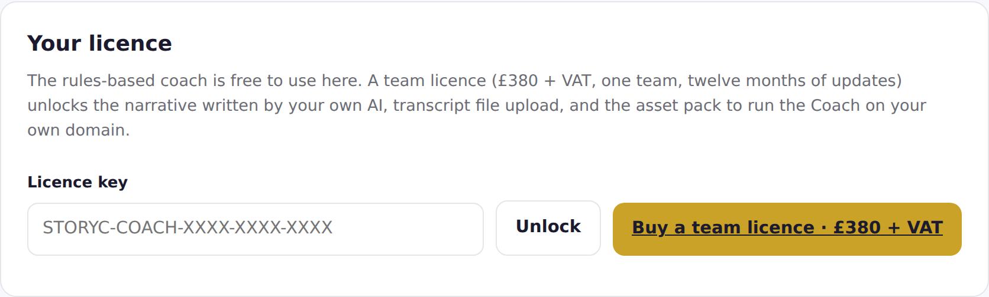
- Click the gold Buy a team licence button. A secure Stripe payment page opens.
- Fill in your email address, your card details or choose to pay by invoice, and, if you like, your organisation name. VAT is added automatically for UK buyers. If you have a VAT number, there is a place to add it so it appears on your invoice.
- Press Pay. Within a few seconds you are sent to your receipt page.
What you will see: A page headed Your Meeting Coach licence, with your licence key in a gold dashed box. It starts STORYC-COACH-.
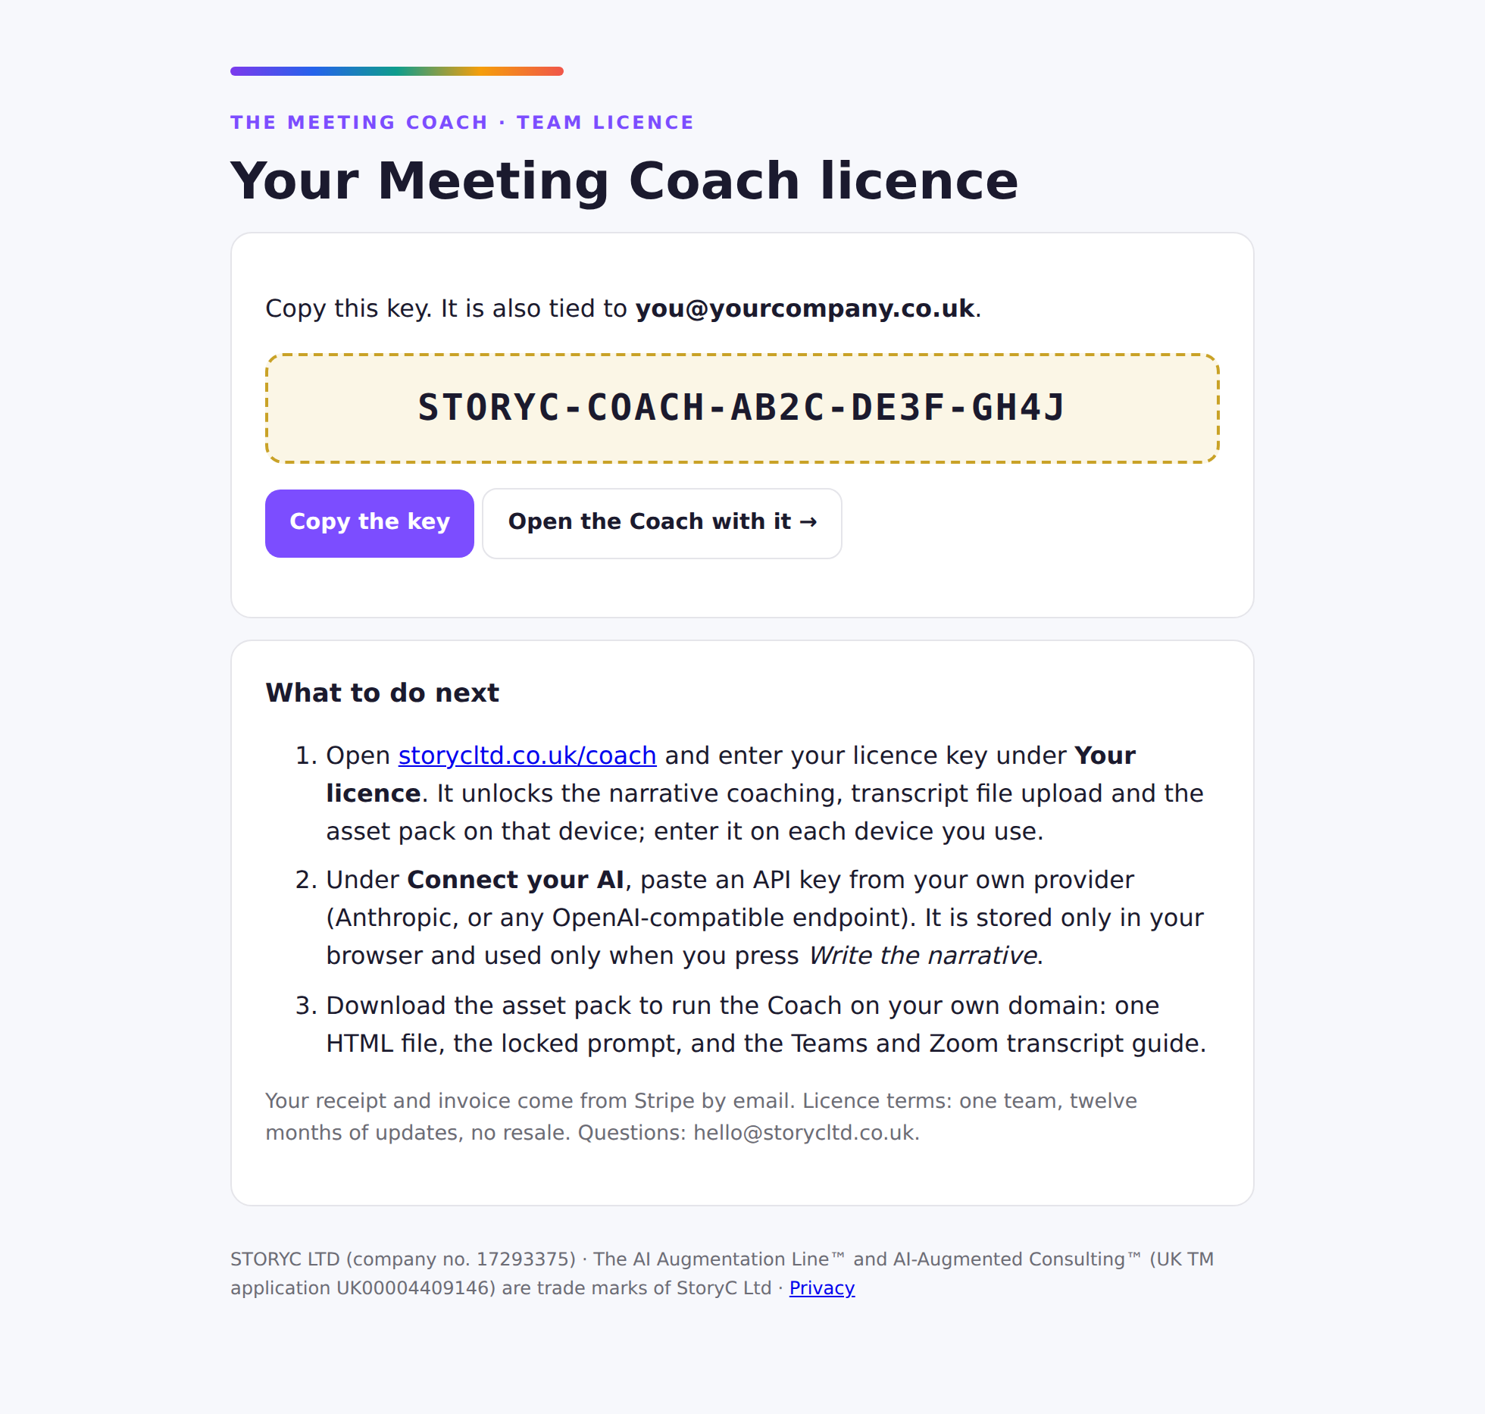
- Click Copy the key. Also write it down or paste it into an email to yourself. Your Stripe receipt and VAT invoice arrive by email separately.
Tip. If the receipt page says the key is on its way, your payment went through and the key will be emailed within one working day. You do not need to pay again.

Step 2 · Unlock the Coach
- Click Open the Coach with it on the receipt page, or go back to storycltd.co.uk/coach and paste the key into the Licence key box, then click Unlock.
What you will see: The words Licence valid, then a green bar saying Licensed, and three new sections appear: Connect your AI, On your phone, and Run it on your own domain.
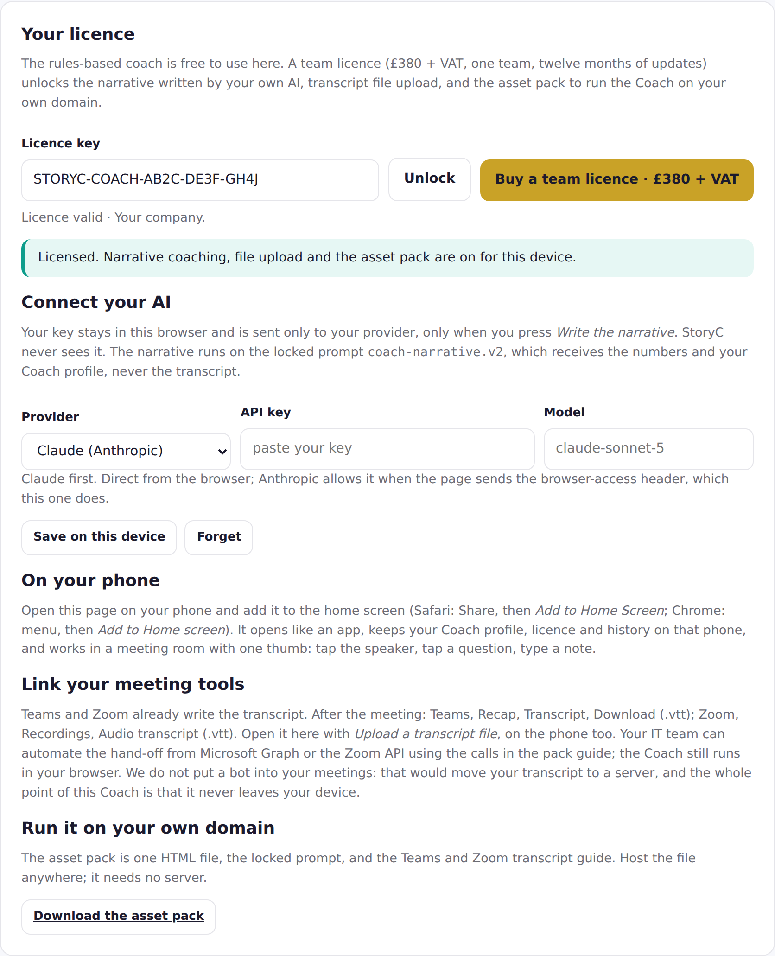
- The key is remembered on that device. Each person on the team enters the same key once on each device they use. One key, one team.

Step 3 · Connect your AI (optional)
The Coach's card, numbers, questions and encouragement work without any AI at all. Connecting an AI adds the written narrative, the tidy notes, the live Ask my Coach button and the development plan. The key you enter stays in your browser and is sent only to your provider, only when you press one of those buttons.

Claude first
- Go to console.anthropic.com, sign in or create an account, and open API Keys. Click Create Key, name it Meeting Coach, and copy the key. It starts sk-ant-. Add a small amount of credit to the account if it asks.
- Back in the Coach, under Connect your AI, leave the provider as Claude (Anthropic), paste the key into API key, and type claude-sonnet-5 as the model.
- Click Save on this device.
What you will see: Saved on this device. The key is shown once; it is stored in that browser only.
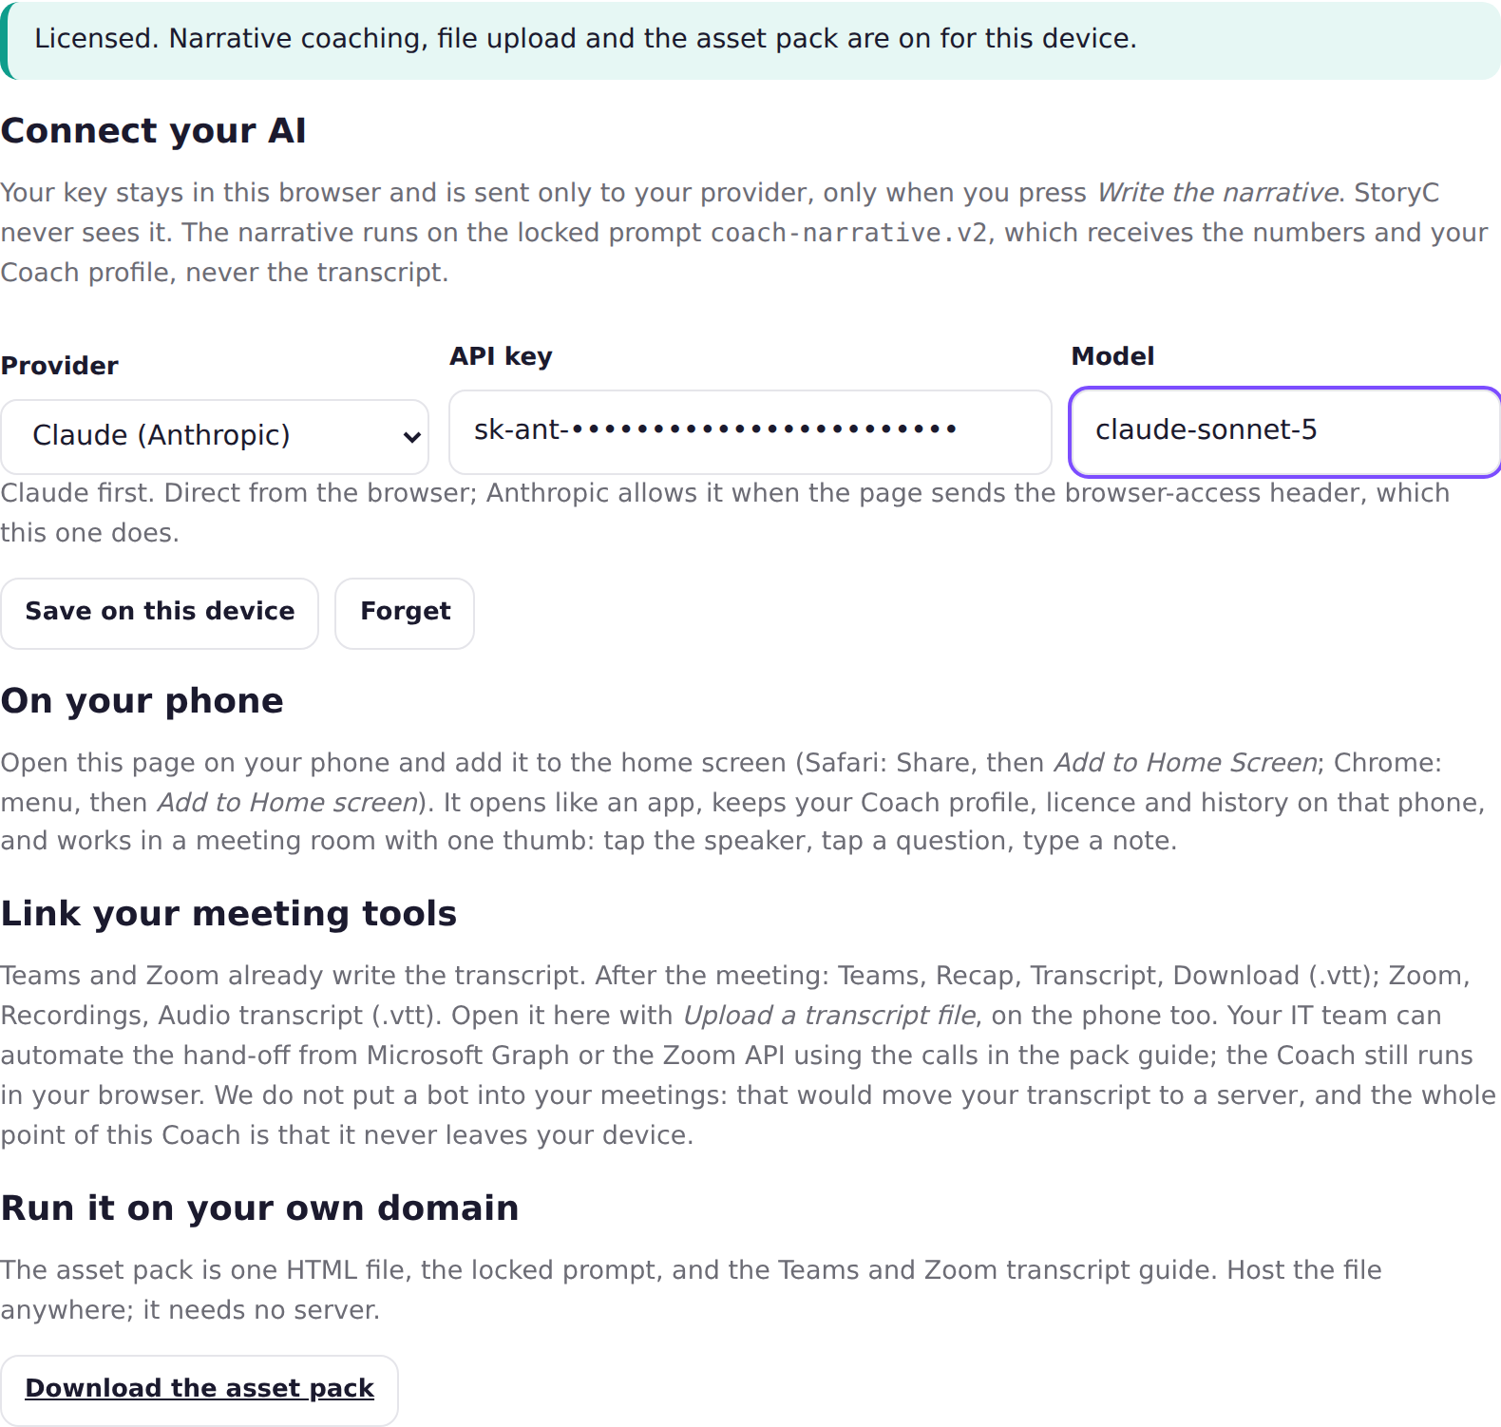

Other providers
Provider | Where to get the key | Model to type
OpenAI | platform.openai.com, API keys | gpt-4o-mini
Azure OpenAI (your IT team) | Your Azure portal; you also need the resource URL and a deployment name | the deployment name
Google Gemini | aistudio.google.com, Get API key | gemini-2.5-flash
Mistral | console.mistral.ai, API keys | mistral-small-latest
Groq | console.groq.com, API keys | llama-3.3-70b-versatile
Ollama on your own computer | No key. Install Ollama and start it with OLLAMA_ORIGINS set to the Coach's address | llama3.2
Choose the provider from the list, and the Coach shows a short hint and fills the endpoint address for you. For Azure OpenAI, enter your resource URL and the deployment name; the Coach uses your company's api-key header.
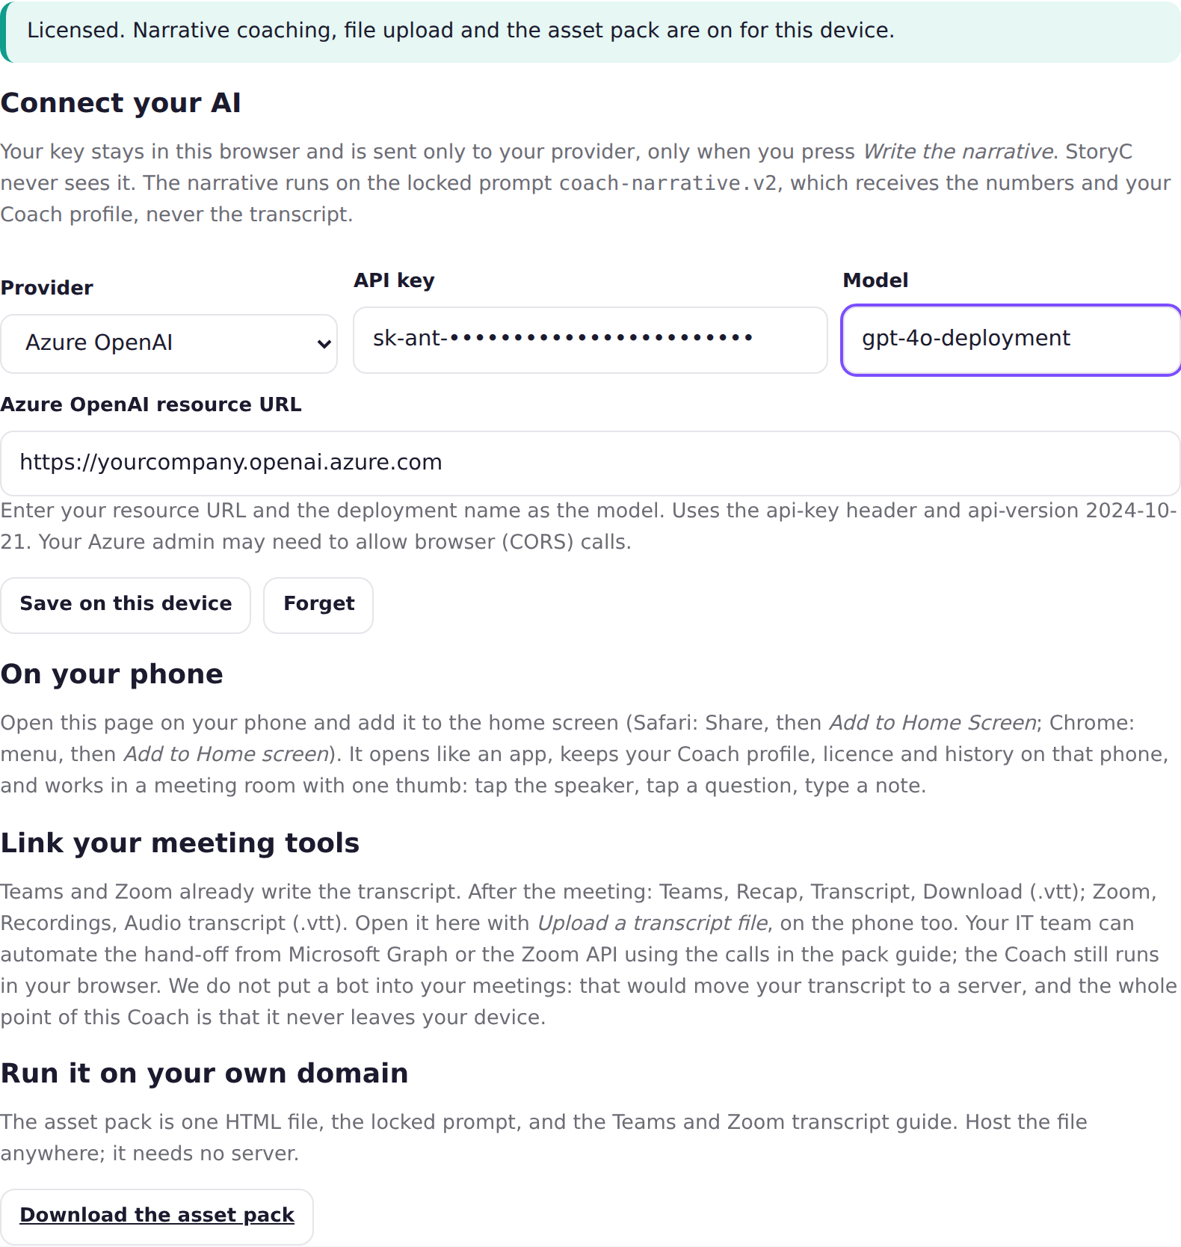
Tip. If a provider blocks calls from a browser (the Coach will tell you: Your provider said…), ask your IT team for a small proxy address and enter it under Other OpenAI-compatible endpoint. Most teams never need this.

Step 4 · Put it on your phone
- Open storycltd.co.uk/coach on your phone, in Safari (iPhone) or Chrome (Android). Enter the licence key once.
- iPhone: tap the Share button (the square with an arrow), scroll down, tap Add to Home Screen, then Add.
- Android: tap the three dots at the top right, tap Add to Home screen, then Add.
What you will see: A Meeting Coach icon on your home screen. It opens like an app, without the browser bar, and keeps your Coach profile, licence and history on the phone.

Step 5 · Add the Invite my Coach button to Outlook (five minutes)
With the button, nobody copies and pastes an invite. Open a meeting in Outlook, click Invite my Coach, click Open in my Coach, and the brief is ready. The button is a small add-in made of two files on the StoryC site. There is no server and nothing is sent to StoryC.
- Copy this address: https://storycltd.co.uk/coach/outlook/manifest.xml
- New Outlook and Outlook on the web: open any email, click the Apps icon (four squares) in the toolbar, then Get add-ins. Classic Outlook for Windows: Home tab, Get Add-ins. Outlook for Mac: Tools, Get Add-ins.
- Click My add-ins on the left. Scroll to Custom Addins, click Add a custom add-in, then Add from URL.
- Paste the address and click OK, then Install.
- Open any meeting in your calendar. Click Invite my Coach in the toolbar, then Open in my Coach.
What you will see: A small panel showing the meeting title, who is invited and the agenda, with a gold Open in my Coach button. The Coach opens in your browser with the invite already read and the gap questions waiting.
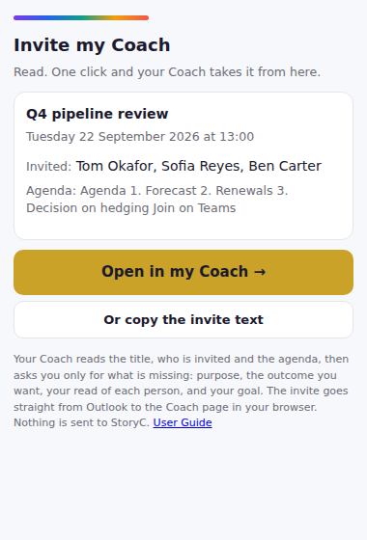
Tip. If your company has switched off custom add-ins, your IT team can add it for everyone in the Microsoft 365 admin centre: Settings, Integrated apps, Upload custom apps, Office Add-in, link to the manifest address above. The Coach works without the button; the button just saves the copy and paste.

Step 6 · Get transcripts from your meetings
The Coach does not record anything. Teams and Zoom write the transcript for you. Here is where to find it.

Microsoft Teams
- Before or during the meeting, click the three dots More, then Record and transcribe, then Start transcription. Everyone in the meeting sees that transcription is on.
- After the meeting, open Teams, click Calendar, click the meeting, then the Recap tab.
- Click Transcript, then the download arrow, and choose .vtt. Save the file somewhere you can find it, such as your Downloads folder.

Zoom
- In your Zoom settings on the web (zoom.us, Settings, Recording), turn on Cloud recording and tick Audio transcript.
- Record the meeting to the cloud. Afterwards go to zoom.us, Recordings, click the meeting, and download Audio transcript (.vtt).

Other tools
Otter, Fireflies, Read and similar tools can export a text file with speaker names. Any file where each line reads Name: what they said will work.
Tip. You can also simply select the transcript text on screen, copy it, and paste it into the Coach. No file needed.

Step 7 · For your IT team (optional)
The team licence includes an asset pack: a single file, coach.html, plus the locked prompts and this guide. Your IT team can put coach.html on your intranet or company web space so the Coach runs under your own address. It needs no server, database or installation, and the instructions are in the pack's GUIDE.md. The Graph and Zoom API calls for fetching transcripts automatically are in the same guide. The Coach still runs in the browser; nothing changes about where the transcript goes.
Download the pack from the Run it on your own domain section once the Coach is unlocked.

If something does not work
What you see | What to do
Licence not recognised | Check the key for typos. It is STORYC-COACH- followed by three groups of four characters. Copy it from your receipt page again.
Could not reach the licence check | Your internet connection dropped for a moment. Wait a minute and click Unlock again.
The narrative button does nothing | Enter your licence key first, then connect your AI (Step 3). The message under the button tells you which one is missing.
Your provider said: API key is invalid | The AI key was copied wrongly or has no credit. Create a new key at your provider and paste it again.
The coach needs a transcript with speaker names | Your transcript has no names. Use the .vtt download from Teams or Zoom, or add Name: at the start of each line.
Nothing tracked yet | In live mode, tap a speaker's name before you press End meeting.
The page looks different on my phone | It is the same page laid out for a small screen. Scroll; every section is there.
Anything else: hello@storycltd.co.uk. Send a photo of your screen if you can.
STORYC LTD (company no. 17293375). The AI Augmentation Line™ and AI-Augmented Consulting™ (UK TM application UK00004409146) are trade marks of StoryC Ltd. The Meeting Coach runs in your browser; your transcript never leaves your device. The machine takes the volume. A named human signs.

