THE MEETING COACH
User Guide
For every member of the team. Your own coach for your own meetings.
StoryC Ltd · The AI Augmentation Line™ · September 2026 · Version 2
Big type, one step at a time, and a picture of what you should see at each step. If a step does not match what is on your screen, stop and email hello@storycltd.co.uk with a photo of the screen. We answer within one working day.

What your Coach does
Your Coach watches one thing: how a meeting actually went. Who held the floor, who asked the questions, who was never asked. It then tells you, plainly, what to do differently next time, and it does the same for the team. It is yours. Nobody sees your card unless you show it to them.
It does not record anything, it never sends your transcript anywhere, and it never calls anyone dominant or quiet. It gives you numbers you can check and one thing to try.
Before a meeting | Paste the invite. Your Coach asks what the invite does not say, and gives you an opening question for each person.
During a meeting | Tap who is speaking, tap a question, type a note. Or do nothing and let the transcript do the work afterwards.
After a meeting | One card: the numbers, what the coach noticed, a question for each person, a word for each person, one move for next time, and a frank word for you.
After ten meetings | Your development plan: the pattern, what has moved, the one practice for the next ten.

Step 1 · Open the Coach
- Type storycltd.co.uk/coach into your browser, or tap the Meeting Coach icon on your phone if it has been added.
- If your team has a licence, paste the key your team lead gave you into Licence key and click Unlock. You only do this once per device.
What you will see: Licence valid, and a green Licensed bar. If you have no key, everything in this guide still works except the written narrative, file upload and the development plan's AI version.

Step 2 · Set up Your Coach (two minutes, once)
This is the part that makes it yours. Scroll to the box called Your Coach.
- Your name. Type it exactly as it appears in meeting transcripts, usually your first name or your full name as Teams shows it.
- Your thinking style. If you have done the Profiler, choose your result. If not, click the Profiler link, spend eight minutes, and come back. Not sure yet is fine for now.
- Your role, and in one line, what the role is for. For example: Head of Corporate Sales; win new corporate clients and grow them onto a second product.
- What you want from your meetings. Pick one: be more assertive, speak out more, ask more and explain less, close more deals, run shorter meetings, bring quieter people in. Or write your own. Pick the one that is actually true for you this quarter.
- How you want to be coached. In real time means nudges and a quick summary during the meeting. Afterwards means nothing during the meeting, one card at the end. Most people start with Afterwards.
- Click Save my Coach.
What you will see: Saved. Your Coach knows you as Priya · goal: Ask more, explain less · after the meeting.
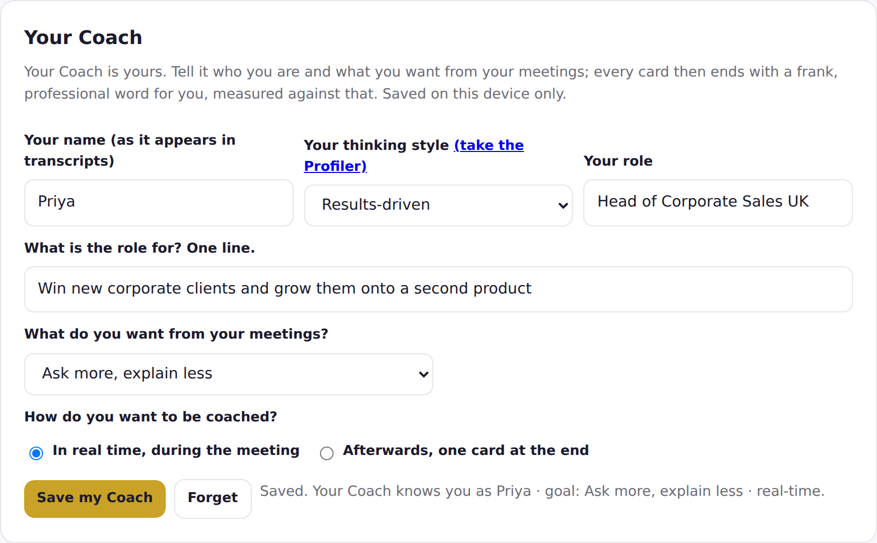
Tip. Your Coach is saved on this device only. If you use a laptop and a phone, set it up on both.

Step 3 · Before a meeting: invite your Coach
The easy way, in Outlook. Open the meeting, click Invite my Coach in the toolbar, then Open in my Coach. The Coach opens with the invite already read; go straight to point 3 below. If you do not see the button, your team lead can add it in five minutes (Installation Guide, Step 5).
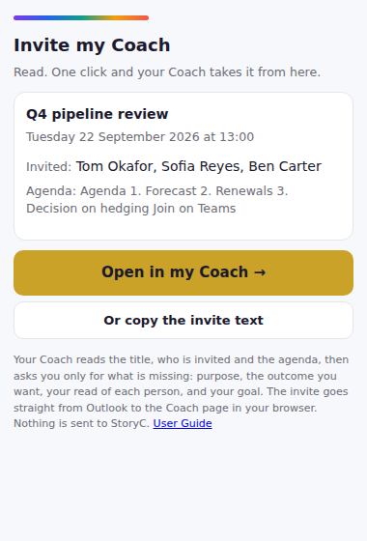
- Without the button: open the meeting in your calendar, select the invite text (title, attendees, agenda), copy it, and paste it into the Before the meeting box. Or download the .ics file from the invite and use Upload the invite.
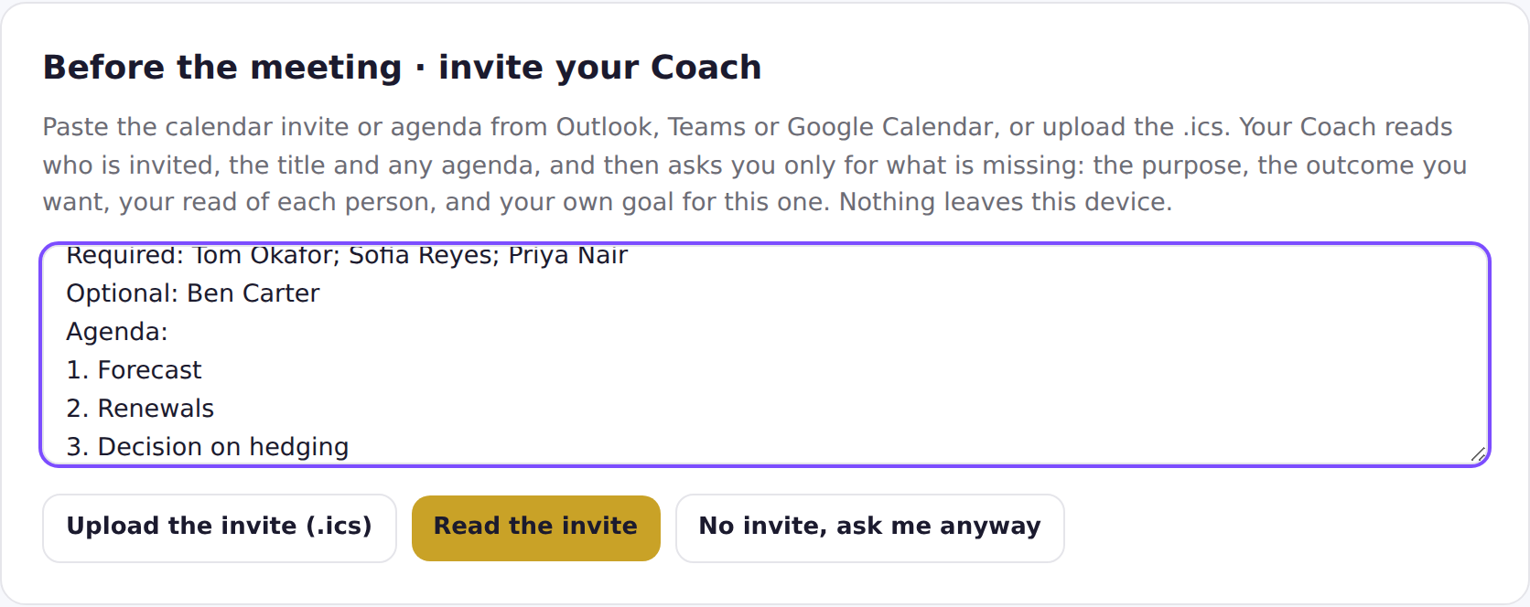
- Click Read the invite.
What you will see: Read: title, 4 invited, agenda. Now the gaps. The people invited appear in the team list below, and your Coach asks you only for what the invite did not say.
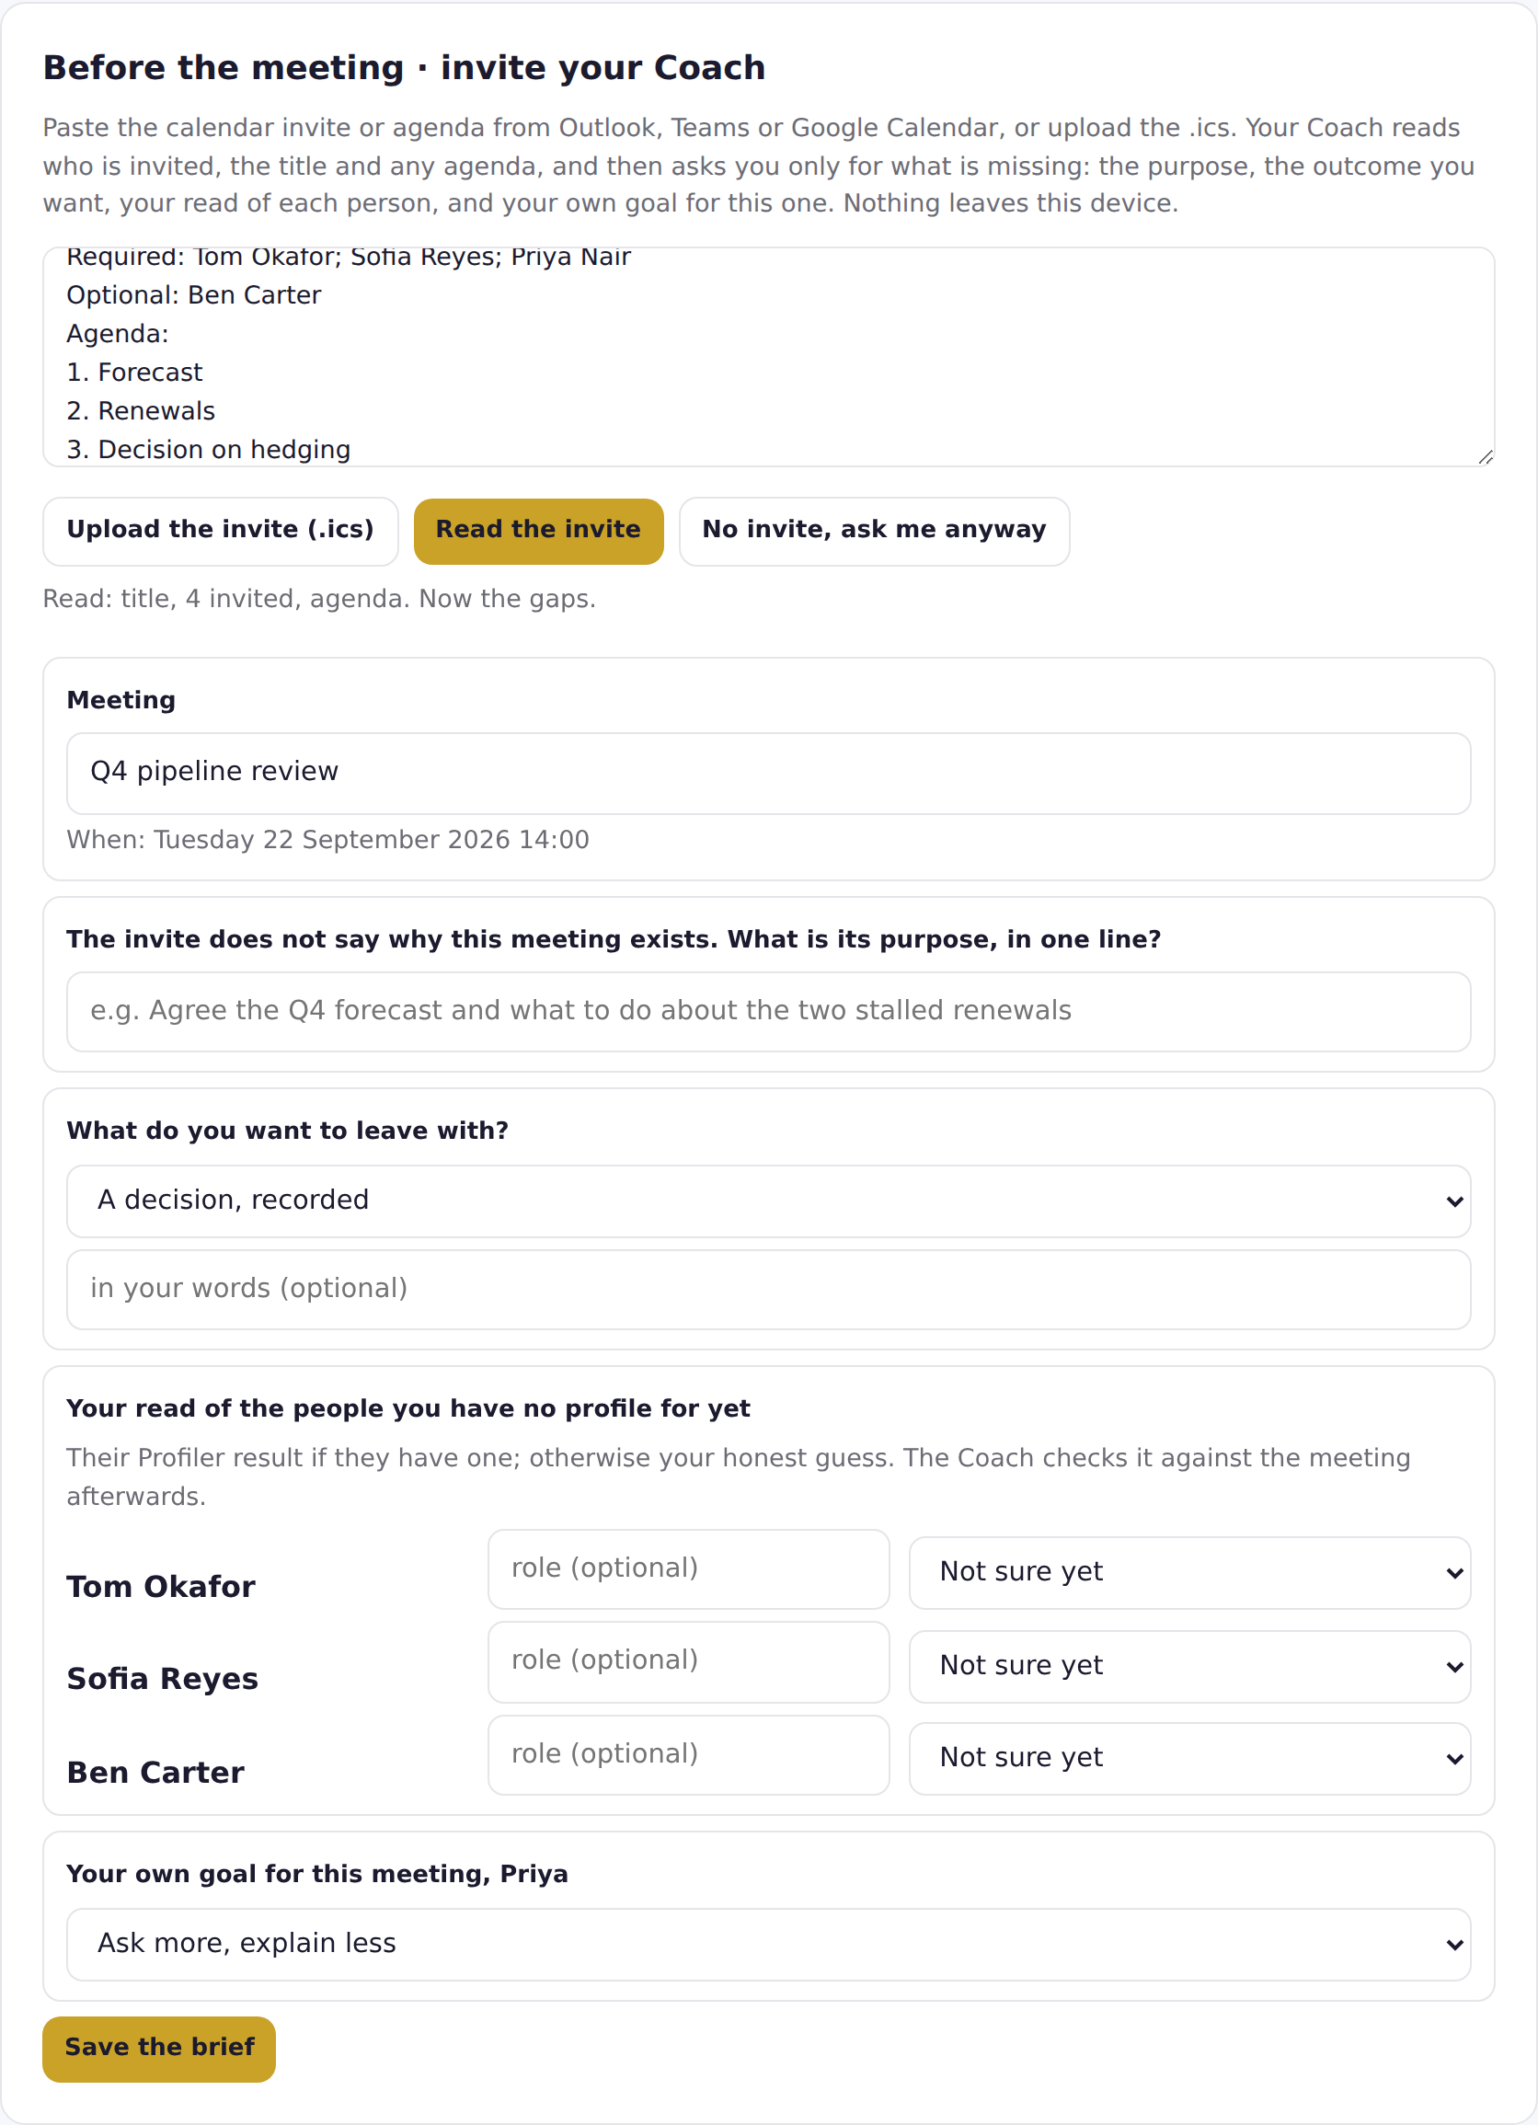
- Purpose. If the invite does not say why the meeting exists, write it in one line. Your Coach will not go into a meeting without it.
- What you want to leave with. A decision, a next step with a date, alignment, information, or a relationship. Your Coach guesses from the agenda; change it if it guessed wrong.
- Your read of each person. For anyone your Coach has no profile for, choose how you think they think. An honest guess is fine; the Coach checks it after the meeting.
- Your goal for this meeting, which starts as your usual goal. Change it if this meeting is different.
- Click Save the brief.
What you will see: The brief: the purpose, what you want, what success will look like on the card, and one opening question for each person written for how they think. Ask the quietest person first.
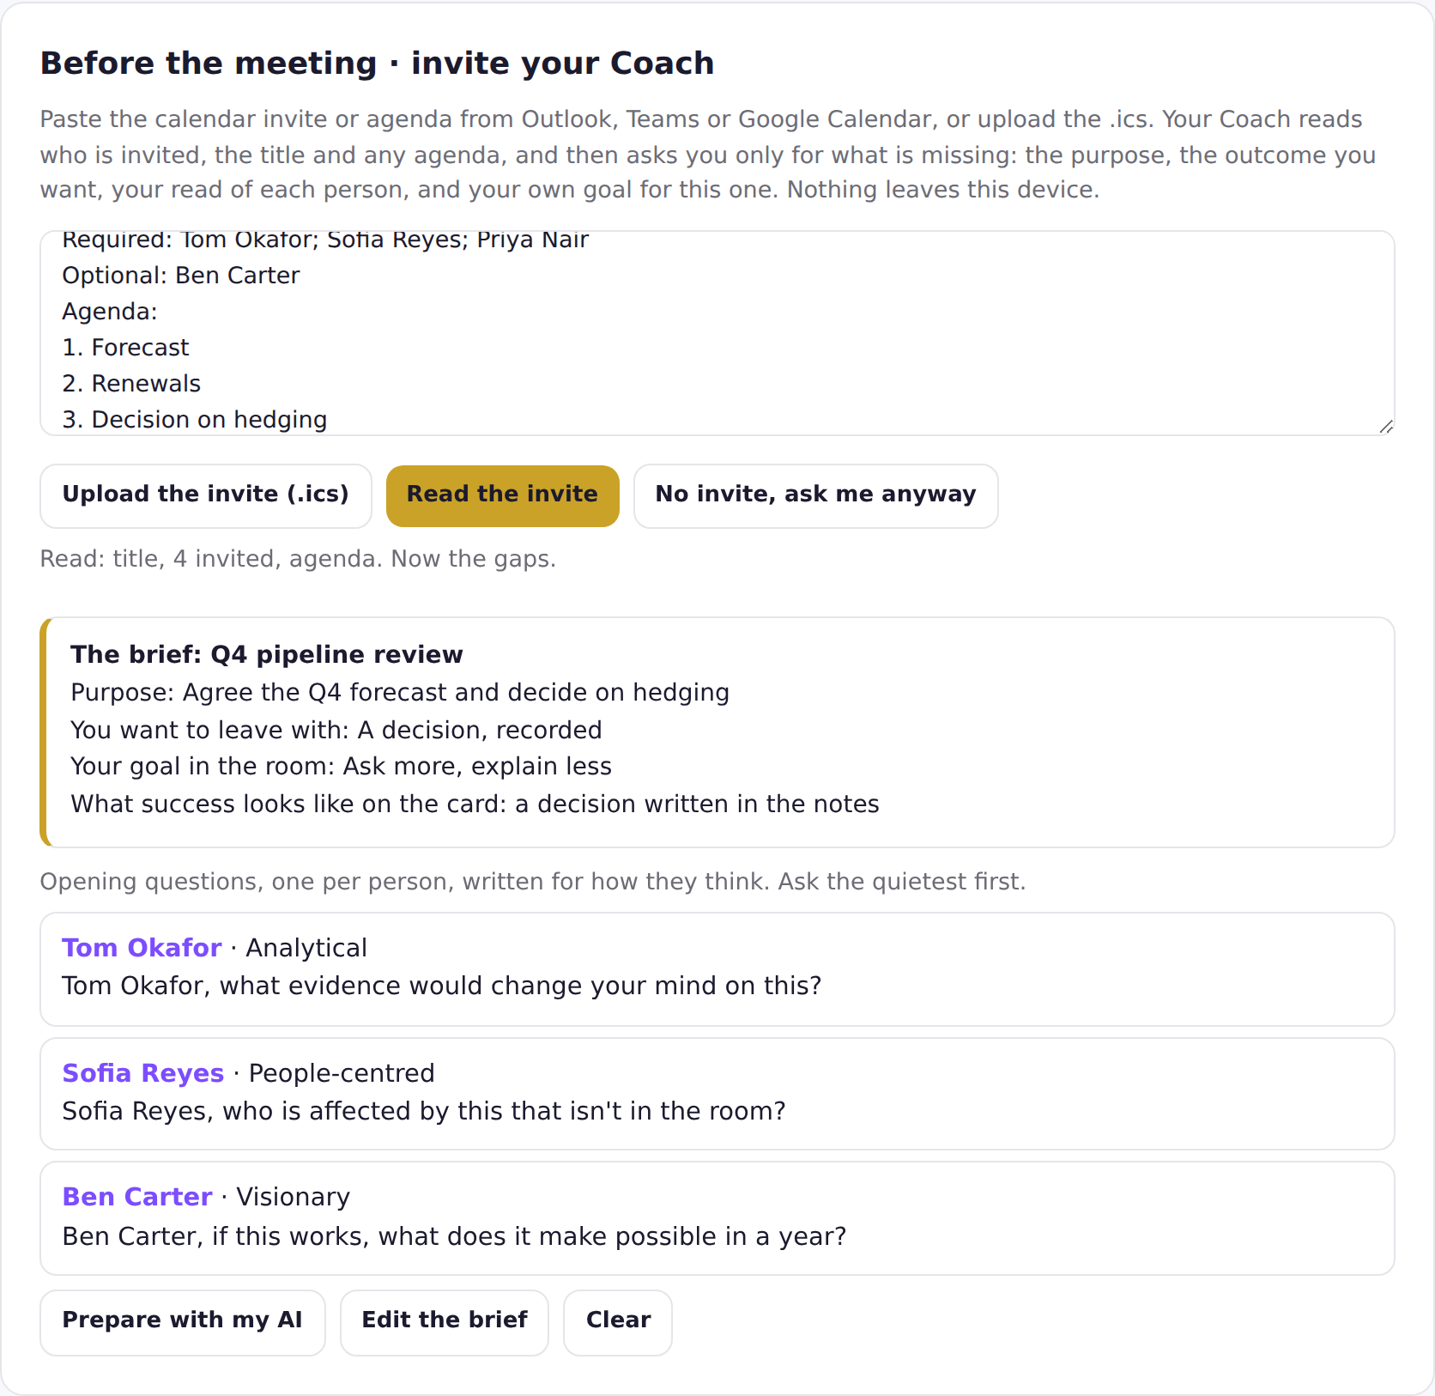

Step 4 · During the meeting (real time)
Skip this step if you chose Afterwards. Otherwise, open the Coach on your phone or a second window and:
- Under 2 · Choose how the coach listens, stay on Live · tap the speaker.
- Tap a person's name when they start speaking. Tap the next person when they take over. Tap the same name again to pause.
- Tap ＋ Question asked whenever the current speaker asks one. Tap ＋ Interruption when someone talks over someone.
- Type a short note and press ＋ Note. Start with Decision: or Action: and the Coach picks it out for the card.
What you will see: Bars showing each person's share of the floor, a quick summary line with your own share and questions against your goal, and from minute five a nudge when one voice has more than forty percent or someone has barely spoken.
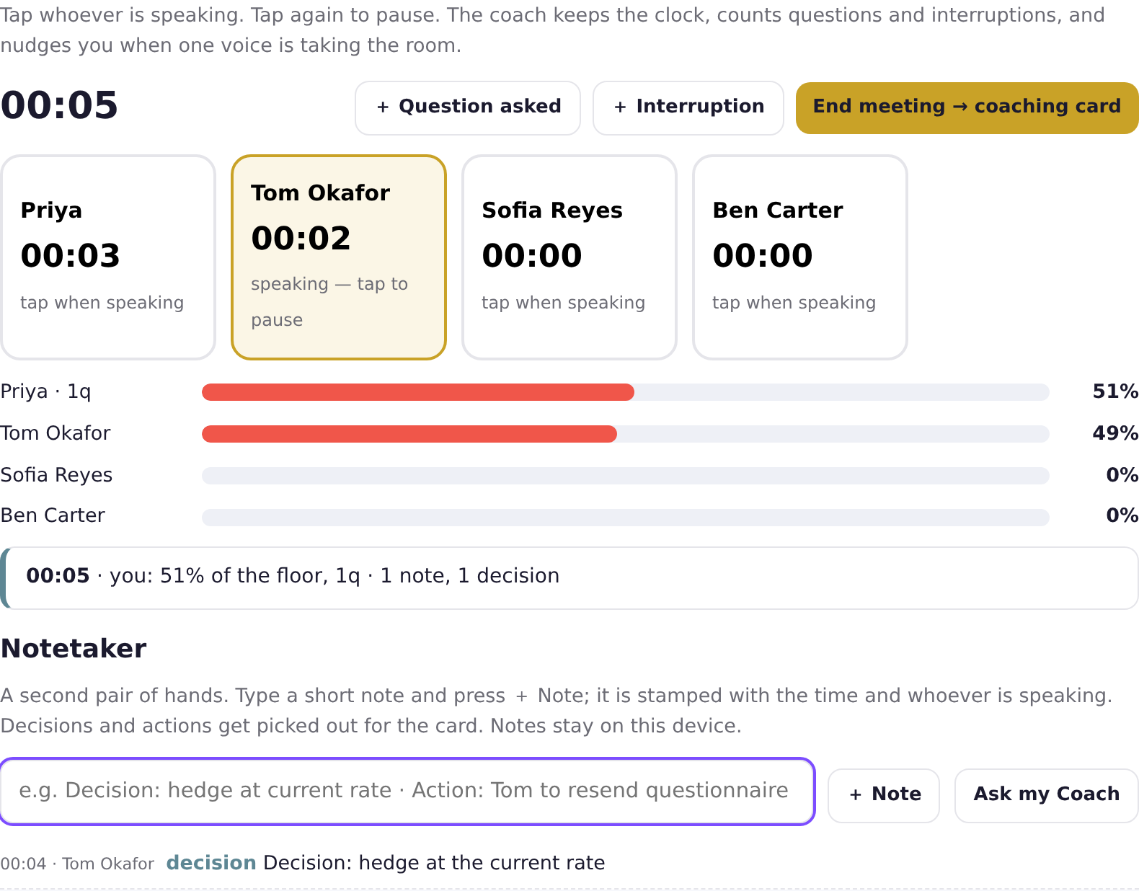
- Licensed and connected to your AI? Press Ask my Coach for one frank sentence on where you stand and one question to ask next. Once a minute at most.
- At the end, press End meeting → coaching card.

Step 5 · After the meeting (transcript)
- Get the transcript: in Teams, Calendar, the meeting, Recap, Transcript, download .vtt. In Zoom, Recordings, the meeting, Audio transcript. Or just copy the text on screen.
- In the Coach, click Afterwards · paste the transcript. Paste the text into the big box, or with a licence click Upload a transcript file and choose the .vtt.
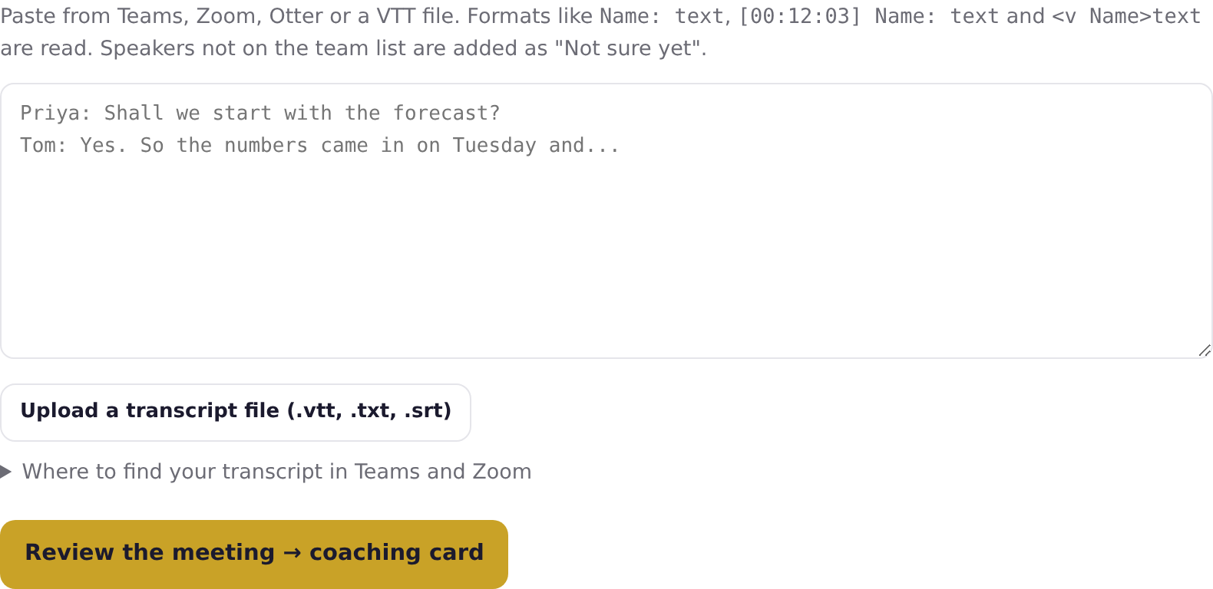
- Click Review the meeting → coaching card.
What you will see: The coaching card appears below. Anyone in the transcript who was not in your team list is added automatically.

Step 6 · Reading your card

The meeting in numbers
One row per person: share of the floor, turns, questions, longest turn and handovers. A fair share is shown so you can compare.
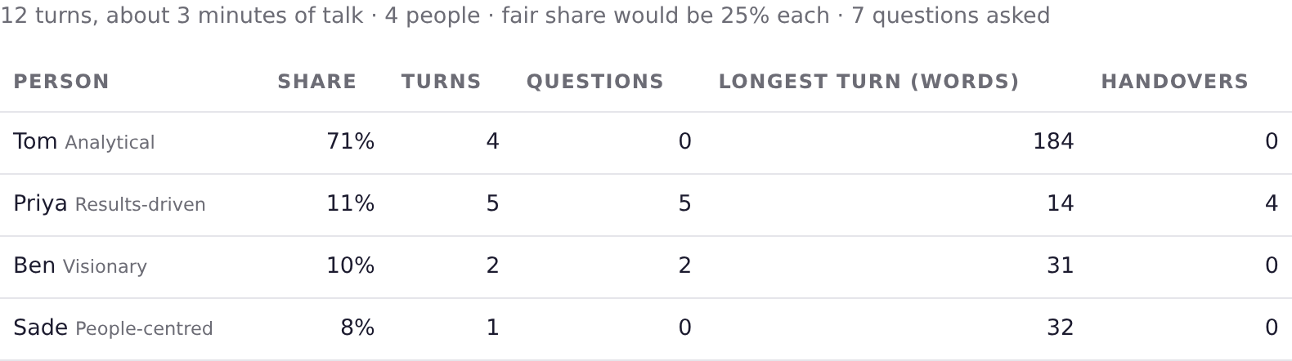

What the coach noticed
Plain statements drawn from the numbers. Nobody is labelled.
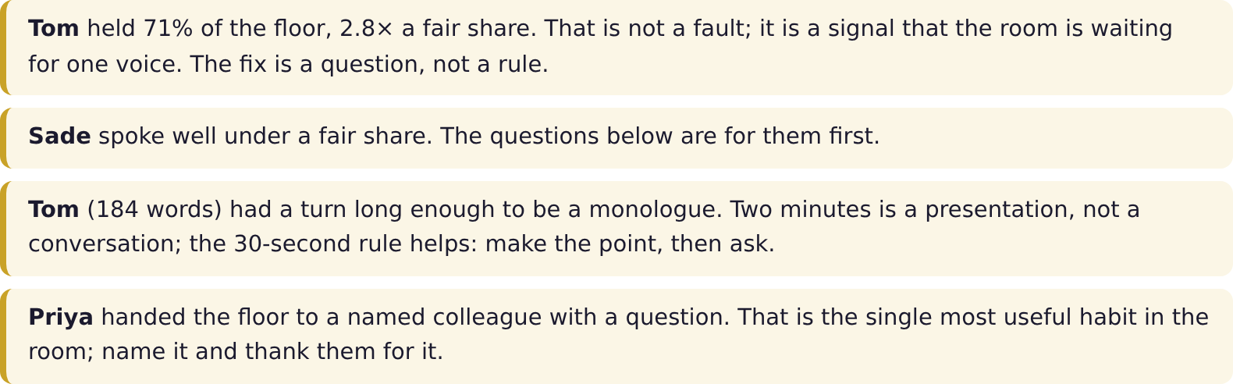

Questions to ask next time
One question per person, written for how that person thinks, with the quietest people first. Use them word for word if you like.
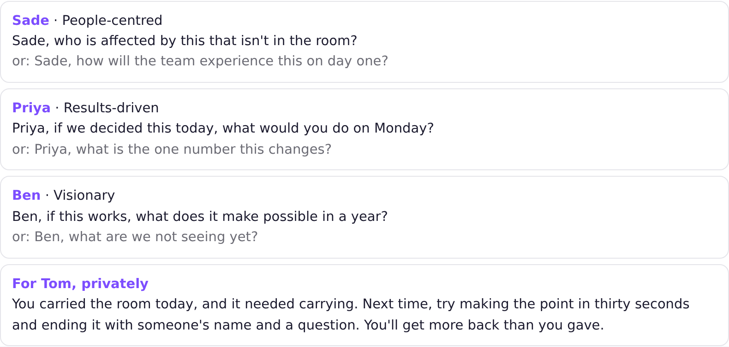

A word for each person
One true thing each. Read them out at the start of the next meeting; it changes the room.
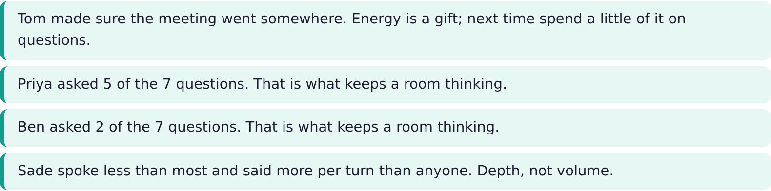

Against the brief and the style check
If you saved a brief, the card says whether you got what you came for, from the numbers and your notes, and asks you to confirm. The style check shows where your read of a person did not match how they behaved. One meeting is one data point; change the read if it repeats.
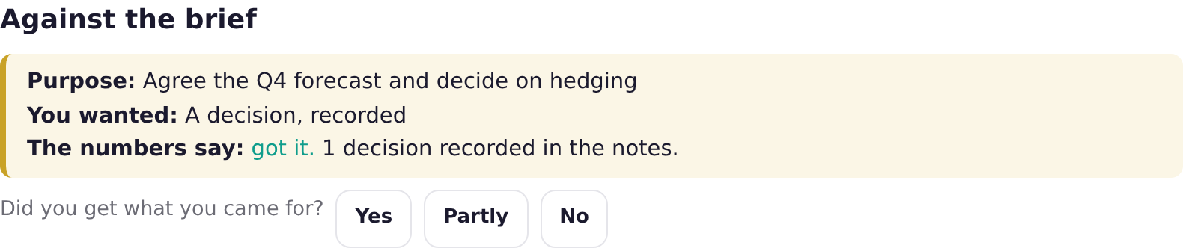
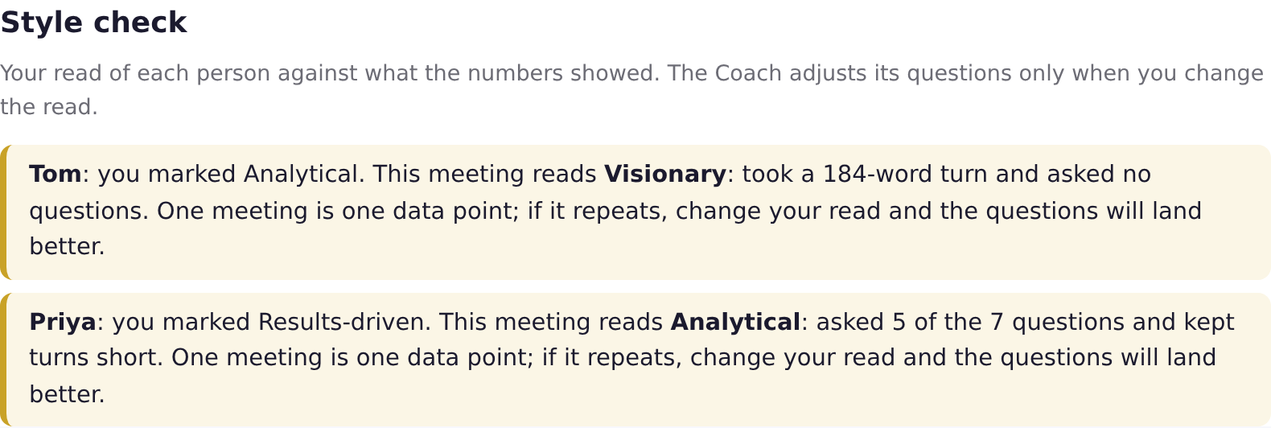

For you
The frank part. On goal or not, the numbers behind it, and one practice for the next meeting. It is measured against the goal you chose, so it is fair, and it is yours alone.
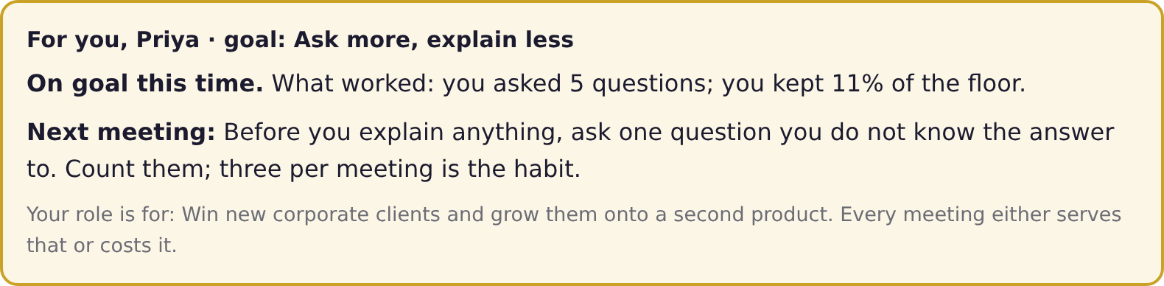

The narrative (licence and your AI)
Press Write the narrative for four short sections you can read aloud, written by your own AI from the numbers only. Read it before you share it.
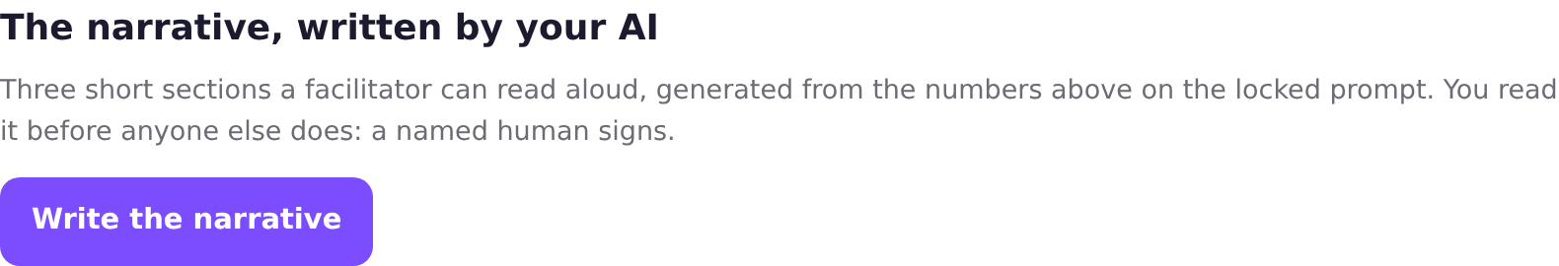
Tip. Copy the card or print it to PDF with the buttons at the bottom of the card. Only the summary numbers are logged to StoryC, never names, never the transcript.

Step 7 · Your progress and your plan
Every card is kept on your device. Your progress shows the last meetings, your share, your questions and whether each was on goal. At ten meetings your development plan appears: the pattern, what has moved, the one practice for the next ten, and a milestone. With your AI connected, Write my development plan adds a fuller version.
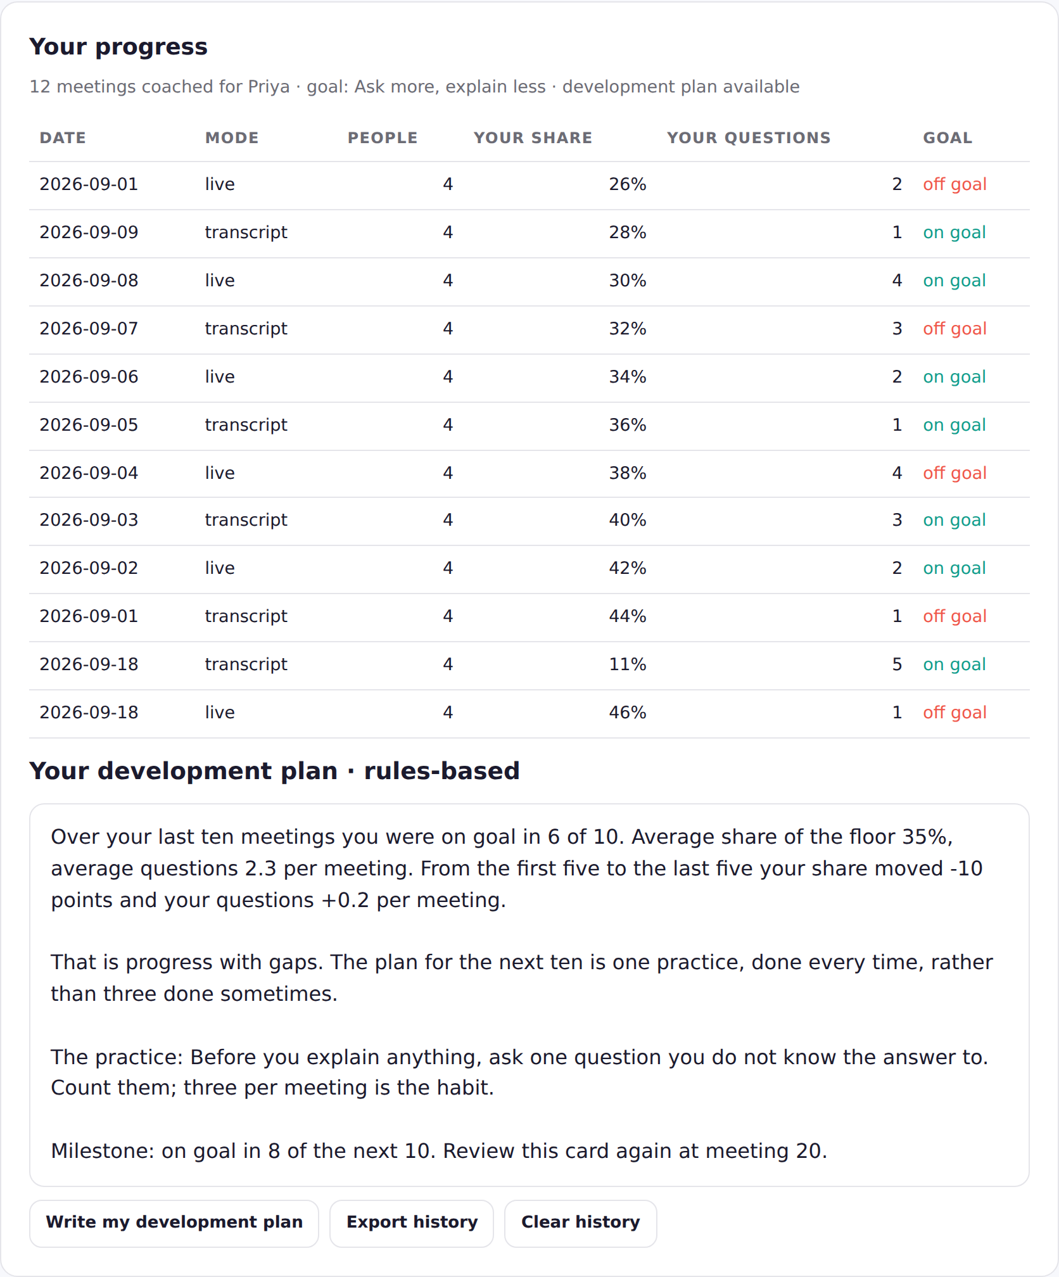
Use Export history to save a copy and Clear history to start again. Nobody else can see it.

Questions people ask
Question | Answer
Does it record the meeting? | No. It reads the transcript Teams or Zoom already made, or your taps.
Where does my transcript go? | Nowhere. It stays in your browser. Only summary numbers (people count, shares, questions) are logged so we can improve the product.
Can my manager see my card? | Only if you show them. Cards and history live on your device.
What if I was not in the transcript? | The card says so and asks you to add yourself to the team as the same name your Coach knows. Check the name matches how Teams writes it.
It says my style read was wrong. Should I change it? | If it repeats over two or three meetings, yes. One meeting is one data point.
Can I use it for a one-to-one? | Yes. Two people, live mode. Most managers are surprised by their own share.
Do I need the AI part? | No. The card, the questions and the encouragement are rules-based and free. The AI adds the written narrative and the fuller plan.
Stuck? hello@storycltd.co.uk, with a photo of your screen.
STORYC LTD (company no. 17293375). The AI Augmentation Line™ and AI-Augmented Consulting™ (UK TM application UK00004409146) are trade marks of StoryC Ltd. The Meeting Coach runs in your browser; your transcript never leaves your device. The machine takes the volume. A named human signs.

